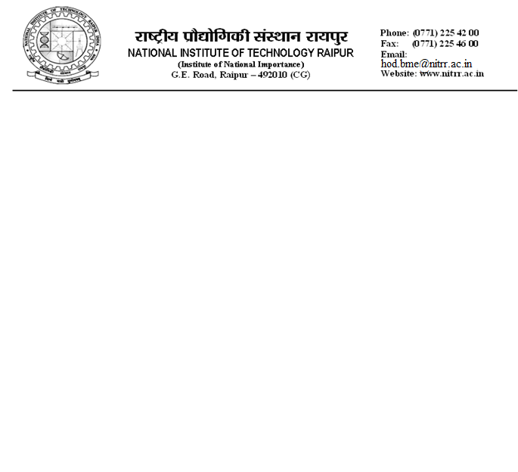
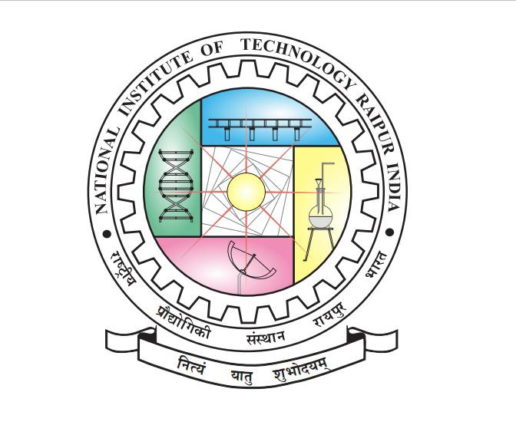

Annexure-1A
No/NITRR/BMD/2026/IIIT-H(NSN)/1 Dated: 13/03/2026
Walk-in Interview for the post of Junior Research Fellow (JRF) in Sponsored R&D Project
Applications are invited for the position of JRF on a purely time-bound research project undertaken at the Department of Biomedical Engineering, National Institute of Technology Raipur, Chhattisgarh, India.
Project Title: | Design and Validation of low-cost multiple wavelength PPG sensor for Non-Invasive detection of graded anemia
Sponsoring Agency: | IIIT-H/Hub
Project Duration: | 1 year
Name of Post | Junior Research Fellow (JRF)
Number of Post | One (01)
Consolidated Monthly Fellowship | Rs. 37,000/- per month + HRA
Duration of the position | Initially, the position is for 3 months, likely to be extended for the remaining duration of the project (Co-terminus with the duration of the project), subjected to the candidate’s satisfactory performance in every 3 months.
Essential qualification | B.E./B.Tech or M.E./M.Tech in Electronics and Communication /Electronics and Electrical Engineering/ Biomedical Engineering / Computer Science and related fields with a minimum of 60% marks or 6.5 CGPA (out of 10) in B.E./B.Tech or M.E./M.Tech.  OR B.E./B.Tech from an Institute of National importance with minimum of 75% marks or 8.0 CGPA (out of 10)
Desirable Qualifications | - Scholars selected through GATE and National Eligibility Tests – CSIR-UGC NET including lectureship (Assistant Professorship).  - Selection through National Level Examinations conducted by Central Government Departments and their agencies and institutions such as UGC / IIT / IISc / DST, etc.  - Strong proficiency in basic hardware (like electronic components, Op-Amps, optical sensors) and computer languages like Python.
Age and Relaxation | Preference will be given to the candidates with the age limit of 35 years
How to apply | Interested applicants may send with the duly filled application form (Annexure-2), relevant mark sheets, certificates, supportive documents, age proof, research experience certificate (if any) and CV as a single pdf file to Dr. Neelam Shobha Nirala, Principal Investigator, Department of Biomedical Engineering, NIT Raipur, Chhattisgarh-492010, via email: neelanir.bme@nitrr.ac.in on or before 26th March 2026, 12:00 PM.
Schedule and venue of the Interview | March 27th 2026, from 10:00 am onwards, at the Department of Biomedical Engineering
Principal Investigator | For any query, the candidates may contact the PI:  Dr. Neelam Shobha Nirala,  email: neelanir.bme@nitrr.ac.in, Mobile: 91-6232089917
Job Responsibilities | Major involvement in design of PPG hardware to acquire data and its processing.
Terms and Conditions: | - No TA/DA is permissible for appearing in the interview.  - The above position is purely temporary, and continuation of fellowship is subject to satisfactory performance review every 4 months and availability of funds.  - The tenure of the position will be initially for 3 months and may be extended based on performance and availability of funds.  - The appointment shall be co-terminus with the project and governed as per the terms and conditions of IIIT-h/Hub funding agency and rules & norms of NIT Raipur.  - The JRF post is purely temporary; the candidate shall not claim regular appointment at this Institute, as the post is co-terminus with the project.  - The JRF post is purely temporary; the candidate shall not claim regular appointment at this Institute, as the post is co-terminus with the project.  - The JRF is required to adhere to the administrative, financial, and disciplinary regulations of the NITRR. Hence, regular attendance of the JRF will be maintained.  - The candidates will have to compulsorily bring the filled-in application form (as per the format annexed), all the original certificates and mark sheets from matriculation onwards, date of birth certificate, NET/equivalent certificate, degree certificate either original or provisional, caste certificate (if applicable), and one set of the self-attested photocopies of all the required certificates from matriculation onwards and an attested copy of recent passport size photograph pasted onto the application form. Proof of experience and publications also need to be submitted.  - Incomplete applications/false information will be summarily rejected.  - Only the candidates meeting essential qualifications would be interviewed.  - No separate call letter shall be sent to the candidates for appearing in the interview.  - Concealing of facts or canvassing in any form shall lead to disqualification or termination of such candidates.  - The Institute reserves the right to cancel the post without assigning any reason.

Dr. Neelam Shobha Nirala
Assistant Professor
Department of Biomedical Engg.
NIT Raipur

